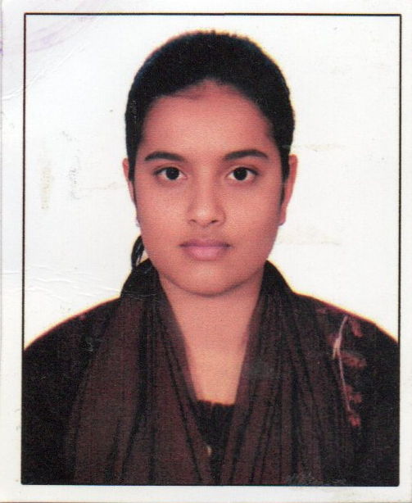

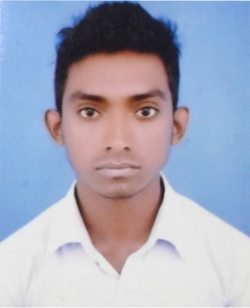CURRICULUM VITAE

**Of**

Atoshi Mohanto

|  |  |  |
| --- | --- | --- |
| **Mailing Address:**  Vill- Kanial Khata,  Post- Kanial Khata  P.S- Nilphamari Sadar,  Dist.- Nilphamari. |  | **Contact Number:**  Mobile: **+88**01740353168  Email: atoshimohonto578@gmail.com |

**Carrier Objective:**

I am a looking for a hand and challenging job where I will have the scope to utilize my knowledge and skills for the development of the institution. I believe I will perform any tasks honestly as my goal.

***Educational Qualification:***

**Program : Higher Secondary Certificate (H.S.C)**

* Name of Institution : Nilphamari govt. College, Nilphamari.

Name of Board : Dinajpur

**HSC**

Group : Humanities

Result : GPA- 5.00 (Out of 5.00)

Year of Passing : 2020

**Program : Secondary School Certificate (S.S.C)**

* Name of Institution : Kanial Khata High School

Name of Board : Dinajpur

**SSC**

Group : Science

Result : GPA- 4.89 (Out of 5.00)

Year of Passing : 2018

**Skill**

* Good Interpersonal Skill
* Good Convincing Power
* Ability to Work Under Pressure
* Good Communication Ability
* Good Leadership Quality

**Computer Knowledge:**

* Operating system : Windows XP, Windows 7, 10
* Database Languages : MS Office, Excel, PowerPoint

**Language Efficiency:**

**Reading Writing Spoken**

English : Excellent Excellent Medium

Bengali (Mother Tung) : Excellent Excellent Excellent

**Strength :**

* Have the adaption capability with new place and people.
* Sincerity in works, honesty and maintaining commitment.
* Good communication skill.
* Decided to work complete all task promptly and to a higher level of quality.
* Creative thinking dedication and hard working.
* Good leadership skills.

**Personal Information :**

* **Name** : Atoshi Mohanto
* Father’s Name : Autul Mohanto
* Mother’s Name : Bijli Mohanto

Permanent Address : Vill- Kanial Khata, Post- Kanial Khata,

P.S- Nilphamari Sadar, Dist.- Nilphamari.

* Date of Birth : 13/01/2003
* Nationality : Bangladeshi
* NID No. : 1527984403
* Religion : Hindu
* Sex : Female
* Marital Status : Unmarried.
* Height : 5′2″
* Weight : 55 kg
* Blood Group : A+ (Positive)

**Declaration:**

I do hereby declare that the above information is true and correct to the best of my Knowledge.

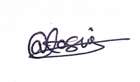

**………………………**

Signature of Applicant